# DESIGN AND IMPLEMENTATION OF INTELLIGENT URBAN IRRIGATION SYSTEM

Community Service Project Report Submitted to the Faculty of

**JAWAHARLAL NEHRU TECHNOLOGICAL UNIVERSITY KAKINADA, KAKINADA**

In partial fulfillment of the requirements for the award of the Degree of

## BACHELOR OF TECHNOLOGY

IN

## download.jpgINFORMATION TECHNOLOGY

**By:**

D.N.V.Nandini Padmaja D.D.N.Sai Ram Prasad (22481A1250) (22481A1243)

D.Yakob A.Farheen

(22481A1252) (22481A1201)

Under the Supervision of

**Sri.Y.K.Viswanadham, M.Tech, Ph.D**

Professor

DEPARTMENT OF INFORMATION TECHNOLOGY

# SESHADRI RAO GUDLAVALLERU ENGINEERING COLLEGE

(An Autonomous Institute with Permanent Affiliation to JNTUK, Kakinada)

SESHADRIRAO KNOWLEDGE VILLAGE, GUDLAVALLERU – 521 356 ANDHRA PRADESH

2024-2025

**Program Book**

**for**

**Community Service Project**



**Name of the Student** :D.N.V.Nandini Padmaja

**Name of the College:** Seshadri Rao Gudlavalleru Engineering College

**Registration Number:** 22481A1250

**Period of CSP:** 8 Weeks **From: To: Name & Address of the Community/Habitation:** Gudivada, Krishna(d),521301

**Community Service Project Report**

Submitted in accordance with the requirement for the degree of Bachelor of Technology

**Name of the College:** Seshadri Rao Gudlavalleru Engineering College

**Department:** Information Technology

**Name of the Faculty Guide**: Sri.Y.K.Viswanadham M.Tech,(Ph.D).

**Duration of the CSP:** From To

**Name of the Student:** D.N.V.Nandini Padmaja

**Programme of Study**:Design and Implementation of Intelligent Urban Irrigation system

**Year of Study:** III B. Tech, I Sem **Register Number:** 22481A1250 **Date of Submission:**

**Student’s Declaration**

I, E.Vidya Rani a participant in the Community Service Program with Registration No. 22481A1250 from the Department of Information Technology at Seshadri Rao Gudlavalleru Engineering College, hereby declare that I have completed the mandatory community service from to in Gudivada, Krishna District, Andhra Pradesh, under the guidance of Sri.Y.K.Viswanadham, from the Department of Information Technology at Seshadri Rao Gudlavalleru Engineering College, Gudlavalleru..

(Signature and Date)

**Endorsements**

Faculty Guide: Sri.Y.K.Viswanadham M.Tech,(Ph.D) Master of Trainer(S):

Head of the Department: Principal

# Certificate from Official of the Community

This is to certify that D.N.V.Nandini Padmaja Reg. No22481A1250 of Seshadri Rao Gudlavalleru Engineering College underwent community service in Gudivada, Krishna District of Andhra Pradesh from to

The overall performance of the Community Service Volunteer during his/her community service is found to be Satisfactory.

Authorized Signatory with Date and Seal

## ACKNOWLEDGEMENTS

I take this opportunity to thank **Dr.B. Karuna Kumar** Principal of the college, **Dr.D.N.V.S.L.S. Indira** Head of the Department of Information Technology, **Sri.T.Balaji** Community Project Coordinator, **Sri.Y.K.Viswanadham** guiding me to carry out this project.

I would like to acknowledge help of Urban people and irrigation department from Gudivada , **Department of IT**, and my **Parents** for providing all sorts of help carrying out this project. I acknowledge the cooperation of each one whose assistance has been helpful in carrying out this project. Finally, I thank authorities.

## Project Associates:

D.N.V.Nandini Padmaja (22481A1250) D.D.N.Sai Ram Prasad (22481A1243) D.Yakob(22481A1252) A.Farheen(22481A1201)

## CHAPTER 1: EXECUTIVE SUMMARY

**EXECUTIVE SUMMARY**

The implementation of an intelligent urban irrigation system is crucial for improving the efficiency and effectiveness of water delivery services in urban areas. This system focuses on the deployment of irrigation tank trailers that supply water directly to households, addressing the challenges faced by both residents and service providers. Current obstacles include communication barriers, difficulties in scheduling deliveries, and accessibility issues for the tank trailers. By developing a user-friendly digital interface, we aim to streamline interactions between residents and service providers, enabling efficient booking, tracking, and management of water deliveries. This innovative approach promises to enhance service reliability, improve user experience, and foster better communication.

## Learning Objectives and Outcomes:

* Community Engagement
* Project Management
* Team Collaboration
* Communication Skills
* Problem Solving
* Community Impact

## CHAPTER 2: OVERVIEW OF THE COMMUNITY

**Historical Profile of the Community:**

Gudivada is a town in the Krishna district of Andhra Pradesh, India. Its history stretches back thousands of years, with roots in ancient dynasties, religious heritage, and its gradual evolution into a bustling community. Gudivada is home to a diverse population with people from various linguistic, religious, and cultural backgrounds.

## Conclusion:

Even though Gudivada is home to a diverse population with people, In Gudivada, the lack of implementation of intelligent urban irrigation systems continues to challenge water conservation efforts, despite the town's need for efficient resource management due to its reliance on growing urban areas. Traditional irrigation practices dominate, leading to high water consumption and wastage, as they lack precision in water distribution and timing.The absence of coordinated urban planning between local authorities and water management agencies further complicates matters. Different departments often work in isolation, creating disjointed policies and slow decision- making processes that hinder the adoption of intelligent irrigation technology. Public awareness about the benefits of such systems is also limited, reducing community support for the transition from traditional methods. Furthermore, unpredictable weather patterns, with monsoon irregularities, make it challenging to develop consistent protocols for these systems. Without clear governmental regulations or incentives promoting intelligent irrigation adoption, Gudivada struggles to make the shift to efficient water management practices. Addressing these challenges could pave the way for smarter water management in Gudivada, preserving resources for urban needs alike, but until these barriers are resolved, the potential for intelligent irrigation remains largely untapped.

Focusing on the use of irrigation tank trailers that supply water door-to-door to urban households. We identified a problem with the irrigation tank trailer system: urban residents are facing difficulties in scheduling and communicating with the service providers, as well as issues with the accessibility of the tank trailers to their properties. Additionally, irrigation tank trailer drivers are having trouble in locating the correct addresses of residents, which is a time-consuming process.Somewhat we are successful in solving these problems with the help our website. This webpage would allow residents to easily book and track water deliveries by tank trailers. By designing this interface, communication about delivery times and any potential delays would be significantly improved, which would be very helpful for both residents and irrigation tank trailer drivers.

## CHAPTER 3: COMMUNITY SERVICE PART

**The activities done during the community service project are as follows:**

Several actions are involved in conducting a thorough community survey in Gudivada with the goal of comprehending the wants and problems of the local populace. Interviews conducted door-to-door can gather personal viewpoints on a range of topics, including problems faced by urban people. Through direct interaction with the inhabitants during these conversations, important insights into their everyday struggles and lives can be gained.

Focus group conversations, in addition to one-on-one interviews, can promote a group exchange of ideas. These gatherings of community members to exchange ideas on certain subjects enable a deeper investigation of common issues and experiences. Community members can voice their thoughts and add to the survey's qualitative data through focus groups.

Another important task is to observe daily routines and community dynamics. Researchers can gain a deeper understanding of the local way of life, cultural customs, and infrastructure by immersing themselves in the community. This firsthand observation aids in recognizing certain difficulties and chances that the community faces.

In conclusion, a variety of methods, including structured surveys, observational studies, focus groups, door-to-door interviews, and community activities, are used in Gudivada community surveys. By capturing the diversity of the community's experiences, this all-encompassing approach hopes to provide insights for customized projects that meet their unique requirements and promote growth.

## ACTIVITY LOG FOR THE FIRST WEEK

|  |  |  |  |
| --- | --- | --- | --- |
| **DAY & DATE** | **BRIEF DESCRIPTION OF THEDAILY ACTIVITY** | **LEARNING OUTCOME** | **PERSON IN- CHARGE SIGNATUR E** |
| **Day –1** |  |  |  |
| **Day –2** |  | . |  |
| **Day –3** | . |  |  |
| **Day –4** |  |  |  |
| **Day –5** |  |  |  |
| **Day –6** |  |  |  |

**WEEKLY REPORT**

## WEEK – 1 (From to )

|  |
| --- |
| **Objective of the Activity Done: Project Initiation and Research** |
| **Detailed Report:** |
| • |
| * . |
| •  . |
| •  . |
| • |
| •  . |
| • |
| •  . |

**ACTIVITY LOG FOR THE SECOND WEEK**

|  |  |  |  |
| --- | --- | --- | --- |
| **DAY & DATE** | **BRIEF DESCRIPTION OF THEDAILY ACTIVITY** | **LEARNING OUTCOME** | **PERSON IN- CHARGE SIGNATURE** |
| **Day –1** |  |  |  |
| **Day –2** |  |  |  |
| **Day –3** |  |  |  |
| **Day –4** |  |  |  |
| **Day –5** |  |  |  |
| **Day –6** |  |  |  |

## WEEKLY REPORT

**WEEK – 2 (From TO )**

|  |
| --- |
| **Objective of the Activity Done: Survey Development &Deployment** |
| **Detailed Report:** |
| • |
| • |
| •  . |
| • |
| • |
| •  . |

**ACTIVITY LOG FOR THE THIRD WEEK**

|  |  |  |  |
| --- | --- | --- | --- |
| **DAY & DATE** | **BRIEF DESCRIPTION OF THE DAILYACTIVITY** | **LEARNING OUTCOME** | **PERSON IN- CHARGE SIGNATURE** |
| **Day –1** |  | . |  |
| **Day –2** |  |  |  |
| **Day –3** |  |  |  |
| **Day –4** |  |  |  |
| **Day –5** |  |  |  |
| **Day –6** |  | . |  |

**WEEKLY REPORT**

## WEEK – 3 (From TO )

|  |
| --- |
| **Objective of the Activity Done: Analysis and Ideation** |
| **Detailed Report:** |
| * . |
| * . |
| • |
| • |
| • |
| • |
| • |
| • |
| • |

**ACTIVITY LOG FOR THE FOURTH WEEK**

|  |  |  |  |
| --- | --- | --- | --- |
| **DAY**  **& DATE** | **BRIEF DESCRIPTION OF THE DAILYACTIVITY** | **LEARNING OUTCOME** | **PERSON IN- CHARGE SIGNATUR E** |
| **Day –1** | . |  |  |
| **Day–2** |  |  |  |
| **Day –3** | . |  |  |
| **Day –4** |  |  |  |
| **Day –5** |  |  |  |
| **Day –6** |  |  |  |

## WEEKLY REPORT

**WEEK – 4 (From TO )**

|  |
| --- |
| **Objective of the Activity Done**: **Trying to analyze the problems in detail** |
| **Detailed Report:** |
| • |
| • |
| • |
| • |
| • |
| • |
| • |
| • |

|  |  |  |  |  |
| --- | --- | --- | --- | --- |
| **ACTIVITY LOG FOR THE FIFTH WEEK** | | | | |
|  | **DAY & DATE** | **BRIEF DESCRIPTION OF THE DAILYACTIVITY** | **LEARNING OUTCOME** | **PERSON IN- CHARGE SIGNATU RE** |
| **Day –1** |  |  |  |
| **Day–2** |  |  |  |
| **Day –3** |  |  |  |
| **Day –4** |  |  |  |
| **Day –5** |  |  |  |
| **Day –6** |  |  |  |
|  | | | | |

## WEEKLY REPORT

**WEEK – 5 (From TO )**

|  |
| --- |
| **Objective of the Activity Done: Development Sprint** |
| • |
| • |
| • |
| • |
| • |
| • |
| • |
| • |
| • |
| • |
| • |

**ACTIVITY LOG FOR THE SIXTH WEEK**

|  |  |  |  |
| --- | --- | --- | --- |
| **DAY & DATE** | **BRIEF DESCRIPTION OF THE DAILYACTIVITY** | **LEARNING OUTCOME** | **PERSON IN- CHARGE SIGNATURE** |
| **Day-1** |  |  |  |
| **Day-2** |  |  |  |
| **Day-3** | . |  |  |
| **Day-4** |  |  |  |
| **Day-5** |  |  |  |
| **Day-6** |  |  |  |

## WEEKLY REPORT

**WEEK – 6 (From TO )**

|  |
| --- |
| **Objective of the Activity Done: Development Sprint** |
| **Detailed Report:** |
| * . |
| • |
| • |
| * . |
| • |
| • |

**ACTIVITY LOG FOR THE SEVENTH WEEK**

|  |  |  |  |
| --- | --- | --- | --- |
| **DAY & DATE** | **BRIEF DESCRIPTION OF THE DAILY ACTIVITY** | **LEARNING OUTCOME** | **PERSON IN- CHARGE SIGNATURE** |
| **Day-1** | . |  |  |
| **Day-2** | . | . |  |
| **Day-3** |  |  |  |
| **Day-4** |  |  |  |
| **Day-5** |  |  |  |
| **Day-6** |  |  |  |

## WEEKLY REPORT

**WEEK-7(From To )**

|  |
| --- |
| **Objective of the Activity Done: Improvement of Features and Refinement** |
| **Detailed Report:** |
| • |
| • |
| • |
| • |
| • |
| • |
| • |
| • |
| • |

## ACTIVITY LOG FOR THE EIGHT WEEK

|  |  |  |  |
| --- | --- | --- | --- |
| **DAY & DATE** | **BRIEF DESCRIPTION OF THE DAILY ACTIVITY** | **LEARNING OUTCOME** | **PERSON IN- CHARGE SIGNATUR E** |
| **Day-1** | . |  |  |
| **Day-2** |  |  |  |
| **Day-3** |  |  |  |
| **Day-4** | . |  |  |
| **Day-5** |  | . |  |
| **Day-6** |  |  |  |

**WEEKLY REPORT**

**WEEK - 8(From To )**

|  |
| --- |
| **Objective of the Activity Done: Final Testing and Future Steps.** |
| **Detailed Report:** |
| * . |
| • |
| * . |
| • |
| * . |
| • |
| • |
| • |
| * . |
| • |
| * . |
| • |
| • |

|  |  |
| --- | --- |
| **CHAPTER 5: OUTCOMES DESCRIPTION**  **Details of the Socio-Economic Survey of the Village/Habitation. Attach the questionnaire prepared for the survey.** | |
|  | **Questionaries:**  1)What is the capacity of urban irrigation tank ? |
| 2) Are there any concerns regarding contamination or pollution of water stored inirrigation  tanks? |
| 3)Is there any direct Interface between irrigation tank trailers and urban residents? |
| 4)Have you encountered challenges with the capacity or size of irrigation tanks in  meeting the water demand for urban areas? |
| 5)what is the capacity of water tank trailers? |
| 6)Have you experienced any issues with water leakage or seepage from irrigation  tank? |
| 7)Have you experienced any problems with the accessibility of the tank trailers to your  property? |
| 8)How effective is the current maintenance of irrigation tanks in preventing issues  like sediment buildup or blockages? |
| 9)How frequently you clean the urban irrigation tank? |
| 10)How often do you see water waste from urban irrigation tanks due to overflow  or improper usage? |
| 11)How important do you think it is for urban irrigation tanks to use rainwater  harvesting techniques? |
| 12)Have you noticed any changes in the usage patterns or management practices  of urban irrigation tanks over time? |
| 13) How many households can be supported by the water in the urban irrigation tanks? |
| 14)Is there any inconvenience or difficulty for the people in accessing water from  urban irrigation tanks? |
| 15)Do you believe that urban irrigation tanks contribute to the overall aesthetics  and livability of your neighborhood? |
| 16)Any urban irrigation tanks are integrated with other water management systems  in city? |
| 17)How filtration or purification systems takes place in urban irrigation tanks ? |
| 18)What improvements or additional features would you like to see in the urban  irrigation tank trailer service? |
| 19)How reliable is the water supply from the urban irrigation tank trailers? |
| 20)How do you ensure compliance with regulatory standards and safety  protocols in the maintenance of irrigation tanks? |
| 21)Have you implemented any measures to improve the efficiency or  sustainability of water usage from the irrigation tanks? |
| 22)What is your primary use of the water supplied by the urban irrigation tank trailer |
| 23))What strategies are implemented to minimize water waste and ensure  sustainable water usage? |
| 24)For how many wards are the urban irrigation tank trailers sufficient? |

|  |  |
| --- | --- |
|  |  |
| 1. What percentage of water comes from municipal/city/county sources, wells, reclaimed water, or other sources? 2. Do you use alternative energy sources for water pumping or irrigation? |
| 27)How do intelligent irrigation systems contribute to water conservation andoverall environmental sustainability in urban areas? |
| 28)How does the implementation of intelligent irrigation systems affect local  communities? |
| 29)What emerging technologies are likely to influence the future design and  capabilities of intelligent irrigation systems? |
| 30)How is the water quality provided by urban irrigation tanks for gardening or  landscaping purposes? |
| 31)Have you encountered any difficulties in scheduling or communicating with theservice providers of the tank trailers? |
| 32)How frequently do you need to irrigate your urban area (e.g., garden, lawn, community  space)? |
| 33)What are the main purposes for your irrigation needs? |
| 34)What is the primary source of your irrigation water? |
| 35)How do you currently irrigate your urban area? |
| 36)What challenges do you face with your current irrigation system? |
| 37)Are you satisfied with the efficiency of your current irrigation system? |
| 38)What improvements would you like to see in urban irrigation systems? |
| 39)How important is sustainability to you in your irrigation practices |
| 40)Would you consider using recycled or alternative water sources (e.g., greywater,  rainwater) for irrigation? |
|  | |

|  |  |
| --- | --- |
| **Describe the problems you have identified in the community.** | |
|  | **1. Current Challenges**: Residents struggle with scheduling water deliveries and lack effective communication channels with service providers, leading to dissatisfaction with the service. |
| **2. Accessibility Issues**: Many urban areas present logistical challenges for tank trailer access, resulting in difficulties for residents receiving their water supply. |
| **3. Inefficient Address Location**: Drivers often encounter problems locating the correct addresses, which contributes to delays in service delivery. |
| **4. Need for a Digital Solution**: A direct interface between residents and service providers is essential to improve service quality and facilitate timely communication regarding deliveries. |
| **5. Webpage Development**: A user-friendly webpage will serve as the primary platform for residents to interact with the irrigation system, offering essential services in a straightforward manner. |
| **6. Real-Time Information**: The system will provide residents with up-to-date information on tank availability and water supply status, enabling informed decision- making. |
| **7. Integrated Booking System**: An intuitive booking system will allow residents to easily schedule water deliveries according to their needs, improving overall service efficiency. |
| **8. Notification Features**: Automated notifications will keep residents informed about delivery times, potential delays, and other important updates. |
| **9. Feedback and Support Mechanisms**: The system will incorporate feedback channels, allowing residents to report issues and provide suggestions for improvement, alongside emergency contact options for urgent support. |
| **10. Enhanced Mapping and Navigation**: Integration of GPS and mapping features will assist drivers in locating residences accurately, minimizing delivery delays and enhancing route efficiency. |
|  | |

|  |  |  |
| --- | --- | --- |
| **Short-term and long-term action plan for possible solutions for the problemsidentified and that could be recommended to the concerned authorities for implementation.** | |  |
|  | **Short-term action plans:** |  |
| 1. **Identify User Requirements :**Conduct user research to identify essential features for the webpage. |  |
| 2. **Develop Basic Webpage Interface :**Create a simple, intuitive webpage design that includes core functionalities like booking and notifications. |  |
| 3. **Integrate Basic Booking System :**Implement an easy-to-use booking system to allow residents to schedule tank trailer deliveries. |  |
| 4. **Provide Basic Tank and Water Availability Information :**Display real-time information about tank availability and water levels. |  |
| 5. **Establish Emergency Contact Support :**Add a visible emergency contact feature for quick support in case of delivery issues. |  |
| 6. **Add Basic Map and Address Locator :**Incorporate a basic map feature to help drivers locate delivery addresses more efficiently. |  |
| 7. **Implement Feedback Mechanism :**Develop a section for residents to leave feedback on services for continuous improvement. |  |
| 8. **Launch Notifications for Bookings :**Enable notifications to confirm bookings and update residents on delivery status. |  |
| 9. **Test Accessibility Features :**Ensure the webpage is accessible to people with disabilities through initial accessibility testing. |  |
| 10. **Create Data Security Measures :**Establish basic security protocols to protect users' personal data. |  |
|  | |  |

|  |
| --- |
| **Long-Term Goals** |
| 1. **Enhance User Interface with Advanced Features :**Refine the webpage interface based on feedback, incorporating more intuitive design elements and advanced features. |
| 2. **Develop Advanced Scheduling and Communication Tools :**Implement dynamic scheduling tools and real-time communication features to improve service reliability. |
| 3. **Introduce Water Usage Analytics :**Add a feature to track and analyze water usage trends for residents, supporting conservation efforts. |
| 4. **Integrate Smart Maps with Real-Time GPS Tracking :**Use GPS to provide real- time location tracking of tank trailers for accurate delivery timing. |
| 5. **Implement Automated Notifications and Reminders :**Set up automated notifications for delivery status, upcoming bookings, and potential delays. |
| 6. **Enable Personalized Resident Profiles :**Allow residents to create profiles with preferences for scheduling, water needs, and contact options. |
| 7. **Optimize for Mobile and Tablet Access :**Ensure the webpage is mobile-friendly to accommodate residents booking from different devices. |
| 8. **Enhance Data Security and Privacy :**Strengthen security measures to safeguard resident and driver information comprehensively. |
| **9.Analyze and Expand Service Coverage :**Assess delivery demand trends and consider scaling up service coverage to meet urban residents' needs more effectively. |

# Description of the Community awareness programme/s conducted w.r.t theproblems and their outcomes.

## Description:

|  |
| --- |
| 1. **Introductory Workshops and Webinars**    * **Description:** Community workshops and webinars were conducted to introduce residents to the irrigation tank trailer booking webpage. These sessions explained the purpose of the platform, its benefits for urban households, and how to use its main features such as booking, notifications, and emergency contacts.    * **Goal:** Ensure residents understand the system’s value in addressing water accessibility challenges and can confidently navigate the platform. |
| 1. **Door-to-Door Information Campaigns**    * **Description:** Teams of volunteers and service representatives visited urban households to provide one-on-one guidance. They distributed informational leaflets, demonstrated the booking process, and answered questions about the tank trailer service and webpage.    * **Goal:** Increase awareness among households unfamiliar with online services and ensure all residents, including the elderly and digitally hesitant, feel supported in using the platform. |
| 1. **Hands-On Training at Community Centers**    * **Description:** Local community centers hosted training sessions where residents could use the webpage on provided tablets or computers. Trainers guided participants through creating bookings, receiving notifications, and accessing emergency support.   **Goal:** Equip residents with practical skills and experience to independently use the webpage, fostering community confidence and ease with the technology. |
| 1. **Public Service Announcements (PSAs)**    * **Description:** The community awareness program included PSAs across local radio, social media, and community boards, highlighting the irrigation tank trailer webpage’s benefits. PSAs emphasized the service's efficiency, reliability, and potential to reduce water wastage.    * **Goal:** Reach a wider audience by spreading key messages on accessible platforms, especially for those who may not attend workshops or webinars. |

|  |  |  |
| --- | --- | --- |
| **Outcomes:** | |  |
|  | 1. **Increased Platform Usage and Booking Efficiency**    * **Outcome:** Following the awareness programs, a significant rise in residents using the webpage to schedule water deliveries was observed. More households were successfully making bookings and utilizing the tracking and notification features, reducing the need for manual scheduling and communication. |  |
| **2. Improved Delivery Timeliness and Address Accuracy**  **Outcome:** With the training on the address locator and mapping features, drivers found it easier to locate delivery points, resulting in faster, more reliable delivery times. This minimized delays and increased service satisfaction for both residents  and drivers |  |
| 1. **Higher Resident Engagement in Water Conservation**    * **Outcome:** Awareness of water conservation practices grew, particularly among urban gardeners and small-scale agricultural users. With information on tracking water usage, residents became more mindful of their water consumption, supporting sustainable urban irrigation. |  |
| 1. **Enhanced Accessibility for Digital Novices**    * **Outcome:** Through workshops and hands-on training, more residents who were previously unfamiliar with online services became comfortable with the webpage. This accessibility improvement helped elderly and digitally inexperienced users gain confidence in scheduling and using the service independently. |  |
| 1. **Positive Community Feedback and System Improvement Suggestions**    * **Outcome:** Feedback mechanisms introduced in the awareness program encouraged residents to share their experiences and suggest improvements. Insights gathered led to ongoing updates in the webpage, such as improved navigation and added customer support, enhancing overall user experience. |  |
|  | |  |

**Project Title: Design and Implementation of Intelligent Urban Irrigation System Introduction:**

Urban irrigation systems are essential infrastructure components designed to manage and distribute water efficiently in urban environments. These systems support the health and aesthetics of green spaces, such as parks, gardens, and street plantings, by providing consistent and controlled water supply. An important component in urban irrigation systems is the use of irrigation tank trailers. These mobile units are equipped with large tanks that can store and transport water to areas where a fixed irrigation infrastructure may not be available or practical.Irrigation tank trailers offer flexibility and efficiency, allowing for targeted watering in areas undergoing maintenance or where temporary irrigation solutions are needed.They are particularly useful in managing water distribution in newly developed urban areas or during drought conditions when water resources need to be carefully managed and mobilized. By integrating tank trailers with traditional irrigation systems, cities can enhance their ability to maintain green spaces and support urban sustainability.

**Problem Statement**:For Urban residents there are difficulties in scheduling and communicating with the service providers, as well as issues with the accessibility of the tank trailers to their properties. Additionally, irrigation tank trailer drivers are having trouble in locating the correct addresses of residents, which is a time-consuming process.

# Objectives:

The main objectives to be fulfilled are :

1. User-Friendly Interface
2. Real-Time Availability and Scheduling
3. Clear Communication Channels
4. Detailed Information and Pricing
5. User Account Management
6. Environmental Impact Information

# Implementations Process:

* To address these problems , we decided to create a user-friendly webpage that includes features such as tank information, water availability, a booking system, notifications, a feedback mechanism, maps and directions, accessibility features, security and privacy measures, and an emergency contact number for quick support in case of issues with the tank trailers.
* The proposed website would allow residents to easily book and track water deliveries by tank trailers. By designing this interface, communication about delivery times and any potential delays would be significantly improved, which would be very helpful for both residents and irrigation tank trailer drivers.
* Defining specific webpages required.
* Planning webpage’s look and structure.
* Designing an user-friendly interface.
* Building webpage using languages like HTML, CSS and JS.
* Collecting and adding the resources.
* Making sure that webpage works well.
* Promoting for the webpage through live interaction with urban residents .

# Code for Website:

**HTML:**

<div><br class="Apple-interchange-newline"><!DOCTYPE html>

<html lang="en">

<head>

<meta charset="UTF-8" />

<meta http-equiv="X-UA-Compatible" content="IE=edge" />

<meta name="viewport" content="width=device-width, initial-scale=1.0" />

<title>water trailer</title>

<link rel="stylesheet" href="style.css" />

<link rel="stylesheet" href="https://cdnjs.cloudflare.com/ajax/libs/font- awesome/6.0.0-beta3/css/all.min.css">

<script src="https://code.jquery.com/jquery-3.6.0.min.js"></script>

<script src="https://cdnjs.cloudflare.com/ajax/libs/typed.js/2.0.12/typed.min.js"></script>

<script src="https://cdnjs.cloudflare.com/ajax/libs/waypoints/4.0.1/jquery.waypoints.min.js"

></script>

<script src="https://cdnjs.cloudflare.com/ajax/libs/OwlCarousel2/2.3.4/owl.carousel.min.js">

</script>

<script src="https://kit.fontawesome.com/269b9c4d7b.js" crossorigin="anonymous"></script>

</head>

<body>

<div class="scroll-up-btn">

<i class="fas fa-angle-up"></i>

</div>

<nav class="navbar">

<div class="max-width">

<div class="logo">

<a href="#">IrrigationTrai<span>ler.</span></a>

</div>

<ul class="menu" style="list-style-type: none; margin: 0; padding: 0;">

<li style="position: relative;">

<a href="#home" class="menu-btn" style="text-decoration: none; padding: 10px; display: block;">HOME</a>

</li>

<li style="position: relative;">

<a href="#about" class="menu-btn" style="text-decoration: none; padding: 10px; display: block;">WATER TRAILERS</a>

<ul style="display: none; position: absolute; top: 100%; left: 0; list-style-type:

none; padding: 0; margin: 0; background: #fff;">

<li><a href="#about-1" style="padding: 10px; display: block; text-decoration: none;">1000liter water trailer</a></li>

<li><a href="#about-2" style="padding: 10px; display: block; text-decoration: none;">2000liter water trailer</a></li>

<li><a href="#about-3" style="padding: 10px; display: block; text-decoration: none;">3000liter water trailer</a></li>

<li><a href="#about-4" style="padding: 10px; display: block; text-decoration: none;">4000liter water trailer</a></li>

</ul>

</li>

<li style="position: relative;">

<a href="#projects" class="menu-btn" style="text-decoration: none; padding: 10px; display: block;">OTHER TRAILERS</a>

<ul style="display: none; position: absolute; top: 100%; left: 0; list-style-type: none; padding: 0; margin: 0; background: #fff;">

<li><a href="#projects-1" style="padding: 10px; display: block; text-decoration: none;">Green Space</a></li>

<li><a href="#projects-2" style="padding: 10px; display: block; text-decoration: none;">Construction</a></li>

<li><a href="#projects-3" style="padding: 10px; display: block; text-decoration: none;">Emergencies</a></li>

</ul>

<script>

// Get the OTHER TRAILERS menu element and its dropdown

const otherTrailersMenu = document.querySelector('li:nth-child(3)'); // Adjust this index based on the actual position in the menu

const otherTrailersDropdown = otherTrailersMenu.querySelector('ul');

// Show dropdown on hover otherTrailersMenu.addEventListener('mouseenter', function() { otherTrailersDropdown.style.display = 'block';

});

otherTrailersMenu.addEventListener('mouseleave', function() { otherTrailersDropdown.style.display = 'none';

});

</script>

</li>

<li style="position: relative;">

<a href="#contact" class="menu-btn" style="text-decoration: none; padding: 10px; display: block;">GET A QUOTE!</a>

</li>

<li style="position: relative;">

<a href="https://indigo-megen-22.tiiny.site" class="menu-btn" style="text-

decoration: none; padding: 10px; display: block;">FEEDBACK</a>

</li>

</ul>

<!-- Language Selector as Menu Button -->

<div class="language-selector" style="position: relative; display: inline-block; margin- left: auto;">

<button onclick="toggleDropdown()" style="padding: 10px; border-radius: 5px; border: 1px solid #ccc; background-color: #f9f9f9; cursor: pointer;">

Select Language

</button>

<div id="dropdownMenu" style="display: none; position: absolute; background-color: #f9f9f9; min-width: 160px; box-shadow: 0px 8px 16px 0px rgba(0,0,0,0.2); z-index: 1; border-radius: 5px;">

<a href="/en" style="color: black; padding: 12px 16px; text-decoration: none; display: block;">English</a>

<a href="maintel.html" style="color: black; padding: 12px 16px; text-decoration: none; display: block;">Telugu (తతతతతత)</a>

</div>

</div>

<script>

// Function to toggle the display of the dropdown menu function toggleDropdown() {

var dropdown = document.getElementById("dropdownMenu"); dropdown.style.display = (dropdown.style.display === "none" ||

dropdown.style.display === "") ? "block" : "none";

}

// Close the dropdown if the user clicks outside of it window.onclick = function(event) {

var dropdown = document.getElementById("dropdownMenu"); if (!event.target.matches('.language-selector button')) {

if (dropdown && dropdown.style.display === "block") { dropdown.style.display = "none";

}

}

}

</script>

<script>

function toggleDropdown() {

var dropdown = document.getElementById("dropdownMenu"); dropdown.style.display = dropdown.style.display === "none" ? "block" : "none";

}

// Close the dropdown if the user clicks outside of it

window.onclick = function(event) {

if (!event.target.matches('.language-selector button')) {

var dropdown = document.getElementById("dropdownMenu"); if (dropdown && dropdown.style.display === "block") {

dropdown.style.display = "none";

}

}

}

</script>

<div class="menu-btn">

<span>☰</span>

</div>

</div>

</nav>

<!-- Home Section Start -->

<section class="home" id="home" style="display: flex; align-items: center; justify- content: center; padding: 50px 0;">

<div class="max-width" style="text-align: center;">

<div class="home-content" style="position: relative; display: inline-block; width: 1250px; height: 500px;">

<!-- Centered Image with Set Dimensions -->

<img src="./image.jpeg" alt="Profile Image" style="width: 100%; height: 100%; object-fit: cover; border-radius: 30px; display: block;">

<!-- Overlay Text and Button on the Image -->

<div style="position: absolute; bottom: 20px; left: 20px; background: rgba(0, 0, 0, 0.6); color: #fff; padding: 10px; border-radius: 5px;">

<p style="margin: 0; font-size: 1.2em;">DESIGN TO PERFORM IN EVERY CHALLENGE!</p>

<a href="https://trailercontact.tiiny.site" target="_blank" style="color: #fff; background-color: #FF0000; padding: 8px 16px; border-radius: 5px; text-decoration: none; display: inline-block; margin-top: 5px;">CONTACT</a>

</div>

</div>

<!-- New Heading and Paragraph under the Image -->

<h2 style="margin-top: 20px; font-size: 2em; color: #FF0000;">Advanced Water Trailer For Every Need!</h2>

<p style="font-size: 1em; color: #FFFFFF;">Irrigation tank trailers are essential in urban settings for maintaining green spaces, providing water to parks and residential gardens. They help control dust on construction sites and unpaved roads, improving air quality and safety. Additionally, these trailers serve as a vital resource during emergencies, supporting firefighting efforts and delivering water for disaster relief, and

plays a vital role in urban by providing flexible, efficient, and effective water management solutions.</p>

</div>

</section>

<!-- About Section Start -->

<section class="about" id="about">

<div class="max-width">

<h2 class="title">WATER TRAILERS</h2>

<div class="about-content" style="display: flex; flex-wrap: wrap; gap: 20px; justify- content: center;">

<!-- Card 1 -->

<div class="column card" style="width: 400px; background-color: #f9f9f9; padding: 15px; border-radius: 10px; text-align: center; box-shadow: 0 4px 8px rgba(0, 0, 0, 0.2);">

<img src="./image.jpeg" alt="Photo 1" style="width: 100%; height: auto; border- radius: 10px;">

<p style="font-size: 0.9em; color: #555; margin: 10px 0;"> 1000 Liter Express Irrigation Trailer System.

</p>

<a href="contact1.html" target="_blank" style="display: inline-block; color: #fff; background-color: #FF0000; padding: 8px 16px; border-radius: 5px; text-decoration: none;">GET A QUOTE</a>

</div>

<!-- Card 2 -->

<div class="column card" style="width: 400px; background-color: #f9f9f9; padding: 15px; border-radius: 10px; text-align: center; box-shadow: 0 4px 8px rgba(0, 0, 0, 0.2);">

<img src="./image.jpeg" alt="Photo 2" style="width: 100%; height: auto; border- radius: 10px;">

<p style="font-size: 0.9em; color: #555; margin: 10px 0;"> 2000 Liter Express Irrigation Trailer System.

</p>

<a href="contact1.html" target="_blank" style="display: inline-block; color: #fff; background-color: #FF0000; padding: 8px 16px; border-radius: 5px; text-decoration: none;">GET A QUOTE</a>

</div>

<!-- Card 3 -->

<div class="column card" style="width: 400px; background-color: #f9f9f9; padding: 15px; border-radius: 10px; text-align: center; box-shadow: 0 4px 8px rgba(0, 0, 0, 0.2);">

<img src="./image.jpeg" alt="Photo 3" style="width: 100%; height: auto; border- radius: 10px;">

<p style="font-size: 0.9em; color: #555; margin: 10px 0;"> 3000 Liter Express Irrigation Trailer System.

</p>

<a href="contact1.html" target="_blank" style="display: inline-block; color: #fff; background-color: #FF0000; padding: 8px 16px; border-radius: 5px; text-decoration: none;">GET A QUOTE</a>

</div>

<!-- Card 4 -->

<div class="column card" style="width: 400px; background-color: #f9f9f9; padding: 15px; border-radius: 10px; text-align: center; box-shadow: 0 4px 8px rgba(0, 0, 0, 0.2);">

<img src="./image.jpeg" alt="Photo 4" style="width: 100%; height: auto; border- radius: 10px;">

<p style="font-size: 0.9em; color: #555; margin: 10px 0;"> 4000 Liter Express Irrigation Trailer System.

</p>

<a href="contact1.html" target="_blank" style="display: inline-block; color: #fff; background-color: #FF0000; padding: 8px 16px; border-radius: 5px; text-decoration: none;">GET A QUOTE</a>

</div>

</div>

</div>

</section

<!-- services section start -->

<section class="projects" id="projects">

<div class="max-width">

<h2 class="title">OTHER TRAILER</h2>

<div class="projects-content">

<div class="carousel owl-carousel">

<a class="alink" href="#home">

<div class="card">

<div class="box">

<i class="fa-solid fa-leaf"></i>

<div class="text">GREEN SPACE</div>

<p>

Irrigation tank trailers are essential for maintaining green spaces in urban areas, ensuring that parks and gardens receive adequate irrigation. They provide a reliable and efficient way to transport and distribute water, promoting healthy plant growth and enhancing the overall aesthetics of the environment.

</p>

</div>

<a href="contact1.html" target="_blank" style="display: inline-block; color: #fff; background-color: #FF0000; padding: 8px 16px; border-radius: 5px; text-decoration:

none;">GET A QUOTE</a>

<br>

</div>

</a>

<div class="card">

<div class="box">

<i class="fa-solid fa-hammer"></i>

<div class="text">CONSTRUCTION</div>

<p>

Irrigation tank trailers play a crucial role in construction sites by providing a

consistent water supply for dust control and site hygiene. They also facilitate concrete mixing and curing, ensuring that construction processes run smoothly and safely while minimizing environmental impact.

</p>

</div>

<a href="contact1.html" target="_blank" style="display: inline-block; color: #fff; background-color: #FF0000; padding: 8px 16px; border-radius: 5px; text-decoration: none;">GET A QUOTE</a>

<br>

</div>

<div class="card">

<div class="box">

<i class="fa-solid fa-exclamation-triangle"></i>

<div class="text">EMERGENCIES</div>

<p>

Irrigation tank trailers are vital during emergencies, supplying essential water

for firefighting efforts and disaster relief operations. Their mobility allows for rapid deployment to affected areas, ensuring access to clean water for both rescue teams and impacted communities.

</p>

</div>

<a href="contact1.html" target="_blank" style="display: inline-block; color: #fff; background-color: #FF0000; padding: 8px 16px; border-radius: 5px; text-decoration: none;">GET A QUOTE</a>

</div>

</div>

</div>

</div>

</section>

<!-- contact section start -->

<section class="contact" id="contact">

<div class="max-width">

<h2 class="title">Contact</h2>

<div class="contact-content">

<div class="column left">

<div class="row-icons">

</div>

<div class="icons">

<div class="row">

<i class="fas fa-user"></i>

<div class="info">

<div class="head">Name</div>

<div class="sub-title">INTELLIGENT URBAN IRRIGATION SYSTEM</div>

</div>

</div>

<div class="row">

<i class="fas fa-map-marker-alt"></i>

<div class="info">

<div class="head">Address</div>

<div class="sub-title">Andhra Pradesh, India</div>

</div>

</div>

<div class="row">

<i class="fas fa-phone"></i>

<div class="info">

<div class="head">Phone #</div>

<div class="sub-title">+91 999999999</div>

</div>

</div>

<div class="row">

<i class="fas fa-envelope"></i>

<div class="info">

<div class="head">Email</div>

<div class="sub-title">

<p[>a](mailto:abcd@gmail.com)b[cd@gmail.com](mailto:abcd@gmail.com)</p>

</div>

</div>

</div>

</div>

</div>

<div class="column right">

<div class="text">REQUEST WATER TRAILER QUOTES!</div>

<form name="submit-to-google-sheet">

<div class="fields">

<div class="field name">

<input type="text" name="Name" placeholder="Name" required />

</div>

<div class="field email">

<input type="email" name="Email" placeholder="Email" required />

</div>

</div>

<div class="field subject">

<input type="message" name="Message" placeholder="REQUIREMENT OF

WATER(in Liters)" required />

</div>

<div class="field address">

<input type="text" name="Location" id="location" placeholder="Address" required />

<button type="button" onclick="openGoogleMaps()">Get Location</button>

</div>

<div class="button">

<button type="submit">BOOK NOW</button>

</div>

</form>

<span id="msg"></span>

</div>

<script src="script.js"></script>

<script>

const scriptURL =

'https://script.google.com/macros/s/AKfycbxPBlyDqoTBUhklDL93VRWU0rIT4Cexk5p nVV2BE-v_F0epcDqMvc6JuaI_MKau3B8R/exec';

const form = document.forms['submit-to-google-sheet']; const msg = document.getElementById("msg");

form.addEventListener('submit', e => { e.preventDefault();

fetch(scriptURL, { method: 'POST', body: new FormData(form)})

.then(response => {

msg.innerHTML = "Message sent successfully. A confirmation email has been

sent.";

setTimeout(function() { msg.innerHTML = "";

}, 2000);

form.reset();

});

})

.catch(error => console.error('Error!', error.message));

function openGoogleMaps() {

const locationInput = document.getElementById("location"); const googleMapsURL = "https://[www.google.com/maps"](http://www.google.com/maps);

// Open Google Maps in a new tab window.open(googleMapsURL, '_blank');

// Set a timeout to allow the user to copy the link manually setTimeout(() => {

// Prompt the user to copy the Google Maps link manually

alert("Please copy the location link from Google Maps and paste it here.");

}, 500);

}

</script>

## Css here:

<div><br class="Apple-interchange-newline">@import url('https://fonts.googleapis.com/css2?family=Poppins:wght@400;500;600;700&famil y=Ubuntu:ital,wght@0,400;0,700;1,400&display=swap');

*{

margin: 0;

padding: 0;

box-sizing: border-box; text-decoration: none;

}

.max-width{

max-width: 1300px; padding: 0 80px; margin: auto;

}

html{

scroll-behavior: smooth;

}

/* nabar styling */

.navbar{ position: fixed; width: 100%;

z-index: 999

padding: 30px 0;

font-family: 'Ubuntu',sans-serif;

transition: all 0.3s ease;

}

.navbar.sticky{ padding: 15px 0;

background-color: crimson;

}

.navbar .max-width{ display: flex;

align-items:center;

justify-content: space-between;

}

.navbar .logo a{ color: #fff;

font-size: 35px; font-weight: 600;

}

.navbar.sticky .logo a span{ color: #fff;

}

.navbar .logo a span{ color: crimson;

}

.navbar .menu li{ list-style: none;

display: inline-block;

}

.navbar .menu li a{ display: block; color: #fff;

font-size: 18px; font-weight: 500;

font-weight: 500; margin-left: 25px;

transition: color 0.3s ease;

}

.navbar .menu li a:hover{ color: crimson;

font-weight: bold;

}

.navbar.sticky .menu li a:hover{ color: #fff;

font-weight: bold;

}

/* menu button styling */

.menu-btn{ color: #fff;

font-size: 23px; cursor: pointer; display: none;

}

/* .scroll-up-btn stlying */

.scroll-up-btn{ position: fixed;

right: 30px; height: 45px; width: 42px;

background: crimson; text-align: center; line-height: 45px; color: #fff;

opacity: 0;

z-index: 99999; font-size: 30px; border-radius: 6px; cursor: pointer;

transition: all 0.3s ease;

}

.scroll-up-btn.show{ bottom: 30px; opacity: 1;

pointer-events: auto;

}

/* about section styling */

.about .about-content .left{ width: 45%;

}

.about .about-content .left img{ height: 400px;

width: 400px; object-fit: cover; border-radius: 6px;

}

.about .about-content .right{ width: 55%;

}

.about .about-content .right .text{ font-size: 25px;

font-weight: 600; margin-bottom: 10px;

}

.about .about-content .right .text span{ color: crimson;

}

.about .about-content .right p{ text-align: justify;

}

.about .about-content .right a{ display: inline-block; background: crimson; color: #fff;

font-weight: 500; font-size: 20px; padding: 10px 30px; margin-top: 20px; border-radius: 6px ;

border: 2px solid crimson ;

}

.about .about-content .right a:hover{ color: crimson;

background: none;

}

/* projects section stylying */

.projects, .teams{ color: #fff; background: #111;

}

.projects .alink{ color: white;

}

.projects .title:before,

.teams .title:before{ background: #fff;

}

.projects .projects-content .card{ background: #222;

text-align: center; border-radius: 6px; padding: 20px 25px; cursor: pointer;

}

.projects .projects-content .card:hover{ background: crimson;

}

.projects .projects-content .card .box{ transition: all 0.3s ease;

}

.projects .projects-content .card i{ color: crimson;

font-size: 50px; transition: color 0.3s ease;

}

.projects .projects-content .card:hover i{ color: #fff;

}

.projects .projects-content .card:hover .box{ transform: scale(1.05);

}

.projects .projects-content .card .text{ font-size: 25px;

font-weight: 500; margin: 10px 0 7px;

}

/* contact section styling */

.contact .title::after{ content: "get in touch";

}

.contact .contact-content .column{ width: calc(50% - 30px);

}

.contact .contact-content .text{

font-size: 20px; font-weight: 600;

margin-bottom: 10px;

}

.contact .contact-content .left p{ text-align: justify;

}

.contact .contact-content .left .icons{ margin: 10px 0;

}

.contact .contact-content .left .row{ display: flex;

height: 65px;

align-items: center;

}

.contact .contact-content .left .row .info{ margin-left: 30px;

}

.contact .contact-content .left .row i{ font-size: 25px;

color: crimson;

}

.contact .contact-content .info .head{ font-weight: 500;

}

.contact .contact-content .info .sub-title{ color: #111;

}

.contact .contact-content .row-icons { float:right;

margin-top: 20%;

width: 10%;

margin-right: 130px;

}

.contact .contact-content .row-icons a i{ margin-top: 5px;

font-size: 25px; color: #fff;

background: crimson; padding: 10px; border-radius: 50%;

border: 2px solid crimson;

}

.contact .contact-content .row-icons a:hover i{ cursor: pointer;

background: none; color: crimson;

}

.contact .right form .fields{ display: flex;

}

.contact .right form .field,

.contact .right form .fields .field{ height: 45px;

width: 100%;

margin-bottom: 15px;

}

.contact .right form .textarea{ height: 80px;

width: 100%;

}

.contact .right form .name{ margin-right: 10px;

}

.contact .right form .email{ margin-right: 10px;

}

.contact .right form .field input,

.contact .right form .textarea textarea{ height: 100%;

width: 100%;

border: 1px solid lightgray; border-radius: 6px; outline: none;

padding: 0 15px; font-size: 17px;

font-family: 'Poppins',sans-serif;

}

.contact .right form .textarea textarea{ padding-top: 10px;

resize: none;

}

.contact .right form .button{ height: 47px;

width: 170px;

}

.contact .right form .button button{ width: 100%;

height: 100%;

border: 2px solid crimson; background: crimson; color: #fff;

font-size: 20px; font-weight: 500; border-radius: 6px; cursor: pointer;

transition: all 0.3s ease;

}

.contact .right form .button button:hover{ color: crimson;

background: none; }

# User Interface of Website:

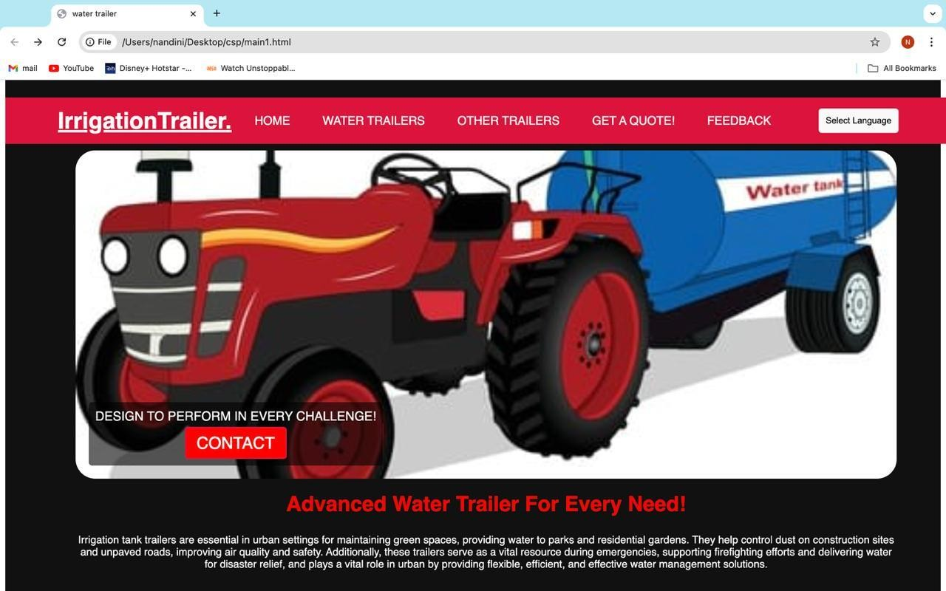

## Fig 1: Home Page

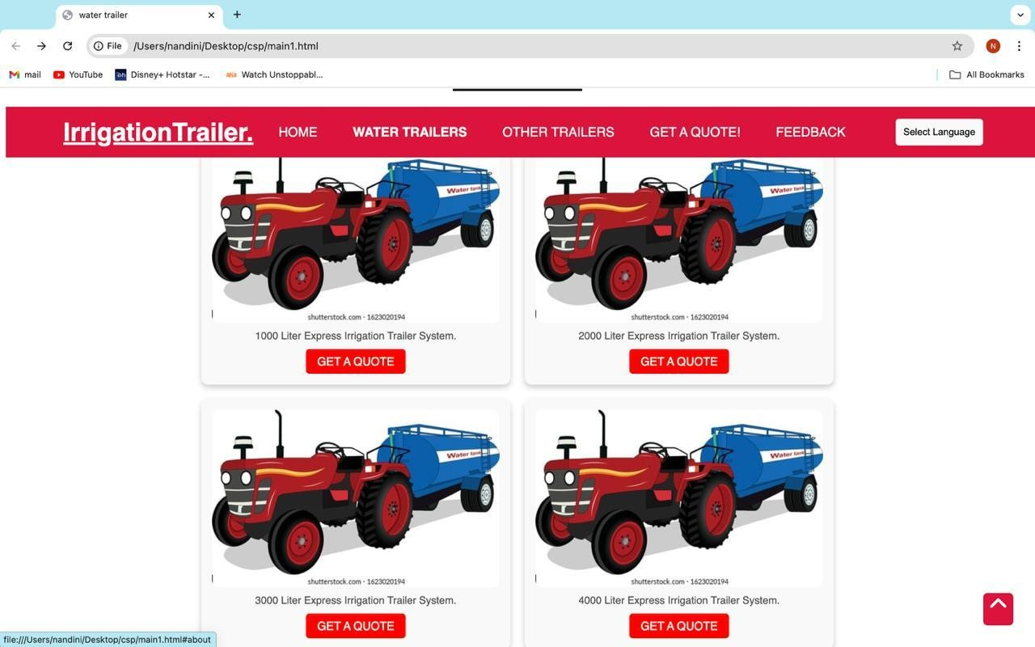

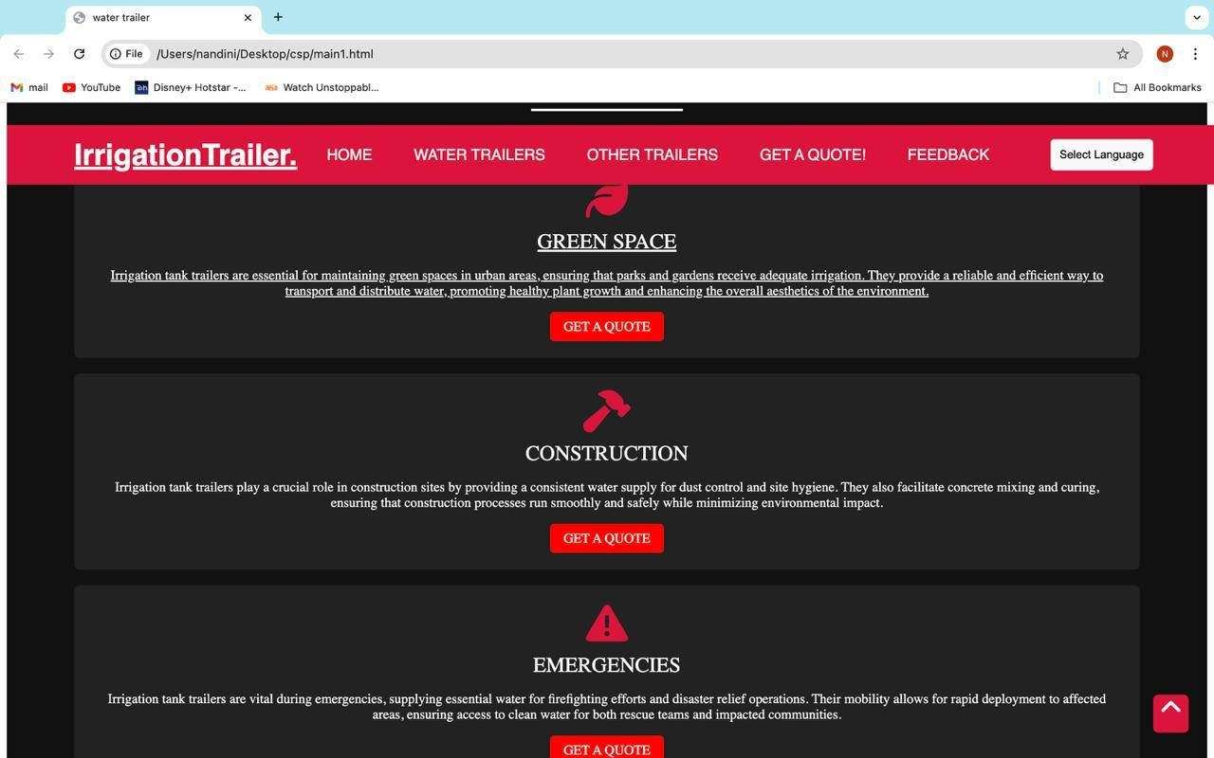

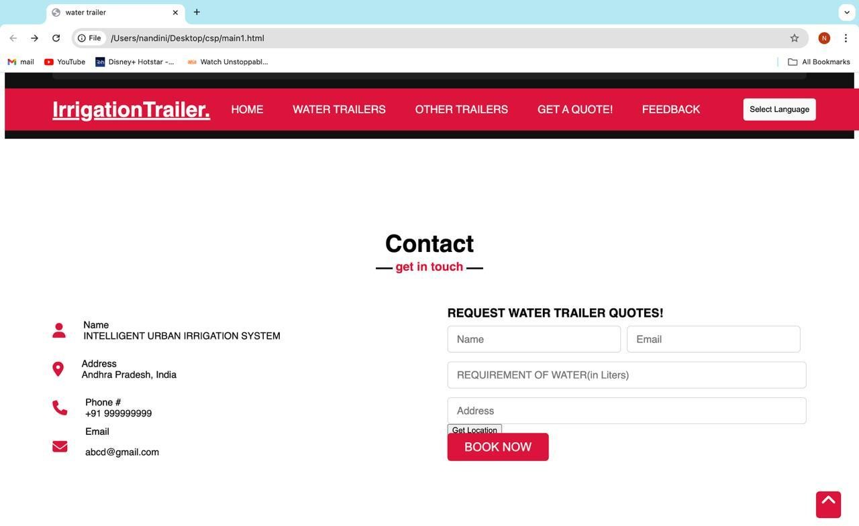

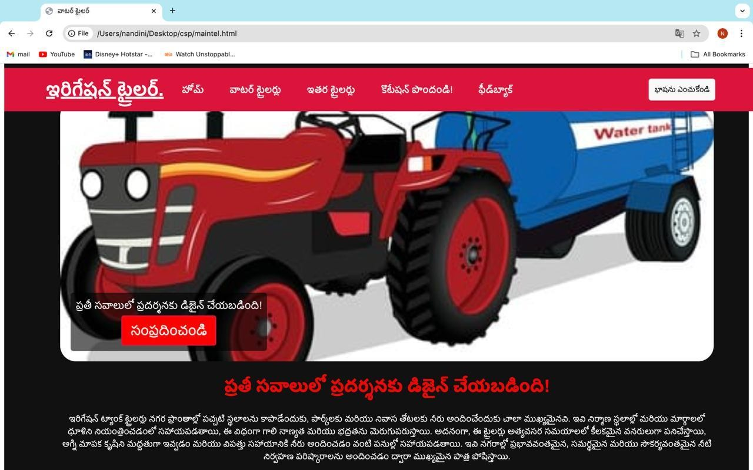**For Telugu Accessibility**

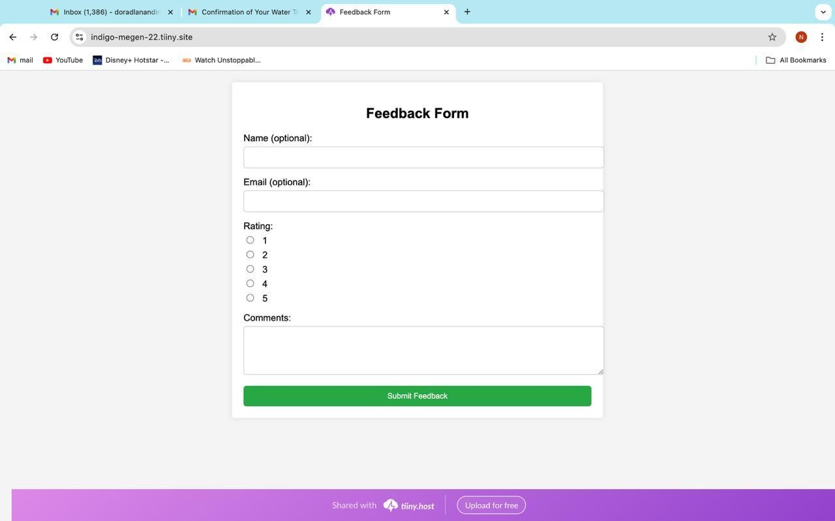

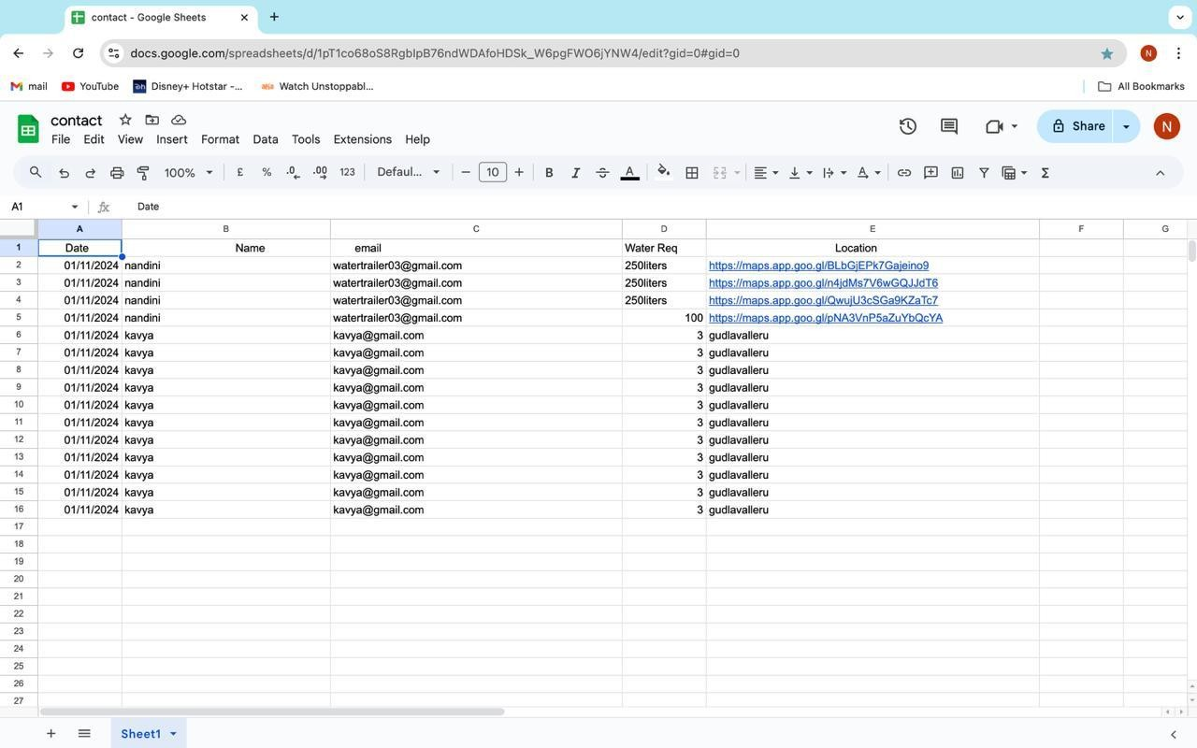

## Order Confirmation to Customer

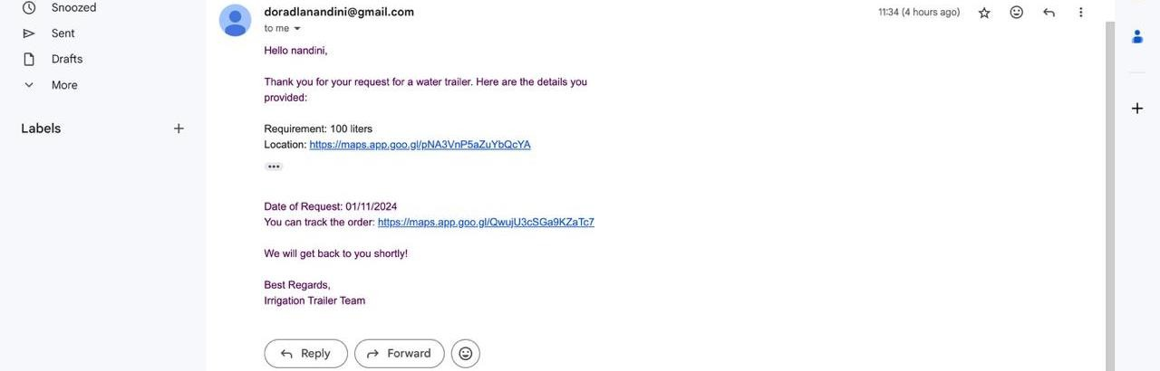

**CHAPTER 6: RECOMMENDATIONS AND CONCLUSIONS OF THE COMMUNITY SERVICE PROJECT**

## Recommendations:

**Develop a Dedicated Online Platform:**

* Create a user-friendly webpage dedicated to managing water deliveries by irrigation tank trailers. This platform should include a booking system, notifications, tank information, and water availability status to provide residents with transparent and up- to-date information.

## Enhance GPS and Mapping Features:

* Integrate robust GPS and mapping features on the platform to assist drivers in locating residents' addresses accurately and efficiently. This will reduce the time and effort spent on locating properties, improving delivery speed and service satisfaction.

## Enable Real-Time Communication:

* Incorporate real-time communication options, such as instant messaging or status notifications, to streamline coordination between residents and drivers. This would allow for quicker updates on delivery times or changes and minimize any scheduling misunderstandings.

## Provide Accessibility and Security Features:

* Ensure that the platform includes accessibility features for all users, such as text-to- speech and adaptable font sizes. Security measures should also be put in place to protect residents' information and ensure a safe booking process.

## Implement Feedback and Emergency Support:

* Include a feedback mechanism for residents to share their experience and report issues, as well as an emergency contact number for urgent assistance. This will improve service quality by allowing timely support and continual service improvements.

## Conclusion:

The introduction of a dedicated webpage for urban irrigation tank trailer systems is essential to addressing scheduling, communication, and accessibility challenges faced by residents and drivers alike. By implementing the recommended features, this platform can foster more efficient water delivery, enhance user satisfaction, and support urban . In the long term, this solution has the potential to modernize water delivery infrastructure, making it more accessible, reliable, and responsive to the needs of urban residents.

## Student Self-Evaluation for the Community Service Project

Student Name:

Registration no: Period of csp:From:

To:

Date of Evaluation:

Name Of the Person in-charge: Address with mobile number:

**Please rate your performance in the following areas:**

**Rating Scale: 1 is lowest and 5 is highest rank**

|  |  |  |  |  |  |
| --- | --- | --- | --- | --- | --- |
| **1) Oral communication** | **1** | **2** | **3** | **4** | **5** |
| **2) Written communication** | **1** | **2** | **3** | **4** | **5** |
| **3) Proactiveness** | **1** | **2** | **3** | **4** | **5** |
| **4) Interaction ability with community** | **1** | **2** | **3** | **4** | **5** |
| **5) Positive Attitude** | **1** | **2** | **3** | **4** | **5** |
| **6) Self-confidence** | **1** | **2** | **3** | **4** | **5** |
| **7) Ability to learn** | **1** | **2** | **3** | **4** | **5** |
| **8) Work Plan and organization** | **1** | **2** | **3** | **4** | **5** |
| **9) Professionalism** | **1** | **2** | **3** | **4** | **5** |
| **10) Creativity** | **1** | **2** | **3** | **4** | **5** |
| **11) Quality of work done** | **1** | **2** | **3** | **4** | **5** |
| **12) Time Management** | **1** | **2** | **3** | **4** | **5** |
| **13) Understanding the Community** | **1** | **2** | **3** | **4** | **5** |
| **14) Achievement of Desired Outcomes** | **1** | **2** | **3** | **4** | **5** |
| **15) OVERALL PERFORMANCE** | **1** | **2** | **3** | **4** | **5** |

**Date: Signature of the Stude**

## Evaluation by the Person in-charge in the Community/Habitation

Student Name:

Registration no:

Period of csp:From: To: Date of Evaluation:

Name Of the Person in-charge: Address with mobile number

**Please rate the student’s performance in the following areas:**

**Please note that your evaluation shall be done independent of the Student’s self- evaluationRating Scale: 1 is lowest and 5 is highest rank**

|  |  |  |  |  |  |
| --- | --- | --- | --- | --- | --- |
| **1) Oral communication** | **1** | **2** | **3** | **4** | **5** |
| **2) Written communication** | **1** | **2** | **3** | **4** | **5** |
| **3) Proactiveness** | **1** | **2** | **3** | **4** | **5** |
| **4) Interaction ability with community** | **1** | **2** | **3** | **4** | **5** |
| **5) Positive Attitude** | **1** | **2** | **3** | **4** | **5** |
| **6) Self-confidence** | **1** | **2** | **3** | **4** | **5** |
| **7) Ability to learn** | **1** | **2** | **3** | **4** | **5** |
| **8) Work Plan and organization** | **1** | **2** | **3** | **4** | **5** |
| **9) Professionalism** | **1** | **2** | **3** | **4** | **5** |
| **10) Creativity** | **1** | **2** | **3** | **4** | **5** |
| **11) Quality of work done** | **1** | **2** | **3** | **4** | **5** |
| **12) Time Management** | **1** | **2** | **3** | **4** | **5** |
| **13) Understanding the Community** | **1** | **2** | **3** | **4** | **5** |
| **14) Achievement of Desired Outcomes** | **1** | **2** | **3** | **4** | **5** |
| **15) OVERALL PERFORMANCE** | **1** | **2** | **3** | **4** | **5** |

**Date: Signature of the Supervisor**

# SURVEY PHOTOS

